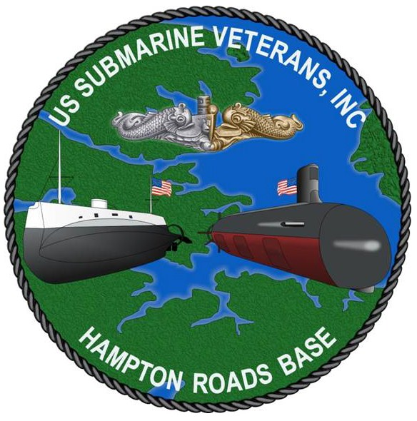
SCHOLARSHIP APPLICATION

for the 2024 – 2025

Scholastic Year

Hampton Roads Base

United States Submarines Veterans, Inc.

The Creed of USSVI:
To perpetuate the memory of our shipmates who gave their lives in the pursuit of their duties while serving their country.
That their dedication, deeds and supreme sacrifice be a constant source of motivation toward greater accomplishments. Pledge loyalty and patriotism to the United States of America and its Constitution.
Part I. Applicant’s Information:

Full Name: |  |  |  | Last Four Digits of Social Security No.:
Date of Birth: |  | Sex: |  | Marital Status:

Permanent (Home) Address: | At School Address:

Mobile Phone Number: |  | Home Phone Number: |  | University Student ID Number:
E-Mail Address:

Part II. Sponsor’s Information:

(Parent, Step-Parent, or Grand-Parent who was Qualified in Submarines and is a member of the Hampton Roads Base)

Name of Sponsor: |  | Relationship to Applicant: |  | Highest Rank/ Rate or Grade:
Year of Qualification in Subs: |  | Submarine Initially Qualified on:

Part III. Education:

Provide the name and address of all the High Schools or accredited institutes of advanced education you are attending, have attended, are graduating from or have graduated from, include the dates attended, and graduation date (past or projected) also specify full or part-time student status (transcripts required):

Part III. Education (Cont.):

Provide the name and address of accredited institute(s) of advanced education to which applicant has applied
(include status of acceptance, intentions of full or part time attendance and planned major):

Part IV. School Transcript Information:

List the school transcripts, for all institutions of learning (listed in Part III. Education above), that are either included with the application or are being sent to the Scholarship Committee separately on your behalf:

Part V. Extra-Curricular Activities and Awards:

List all extra-curricular activities, awards, and honors both in and out of school from your high school period through the time of application include any positions of leadership and detail responsibilities:

Part VI. References:

Provide the names, positions, contact information, and relationships to you, of the two people who will be submitting letters of reference and recommendation to the Scholarship Committee on your behalf:
1.)

2.)

Part VII. Essay

The APPLICANT must submit, along with this application:

- First, submit an original essay of 250 to 500 words maximum discussing the impact of U.S. Submarines during Iraq Wars or the War on Terrorism.
- Second, if you are awarded the USSVI Hampton Roads Base Scholarship you would be expected to be an Ambassador of USSVI. Write a 2nd essay of at least 100 words on how you will live up to our Creed and the values of our organization.
- Third, explain to the Scholarship Committee why you feel you are deserving to be awarded this scholarship of least 100 words.

Signature of applicant: |  | Date:

It is highly recommended that an appropriate representative from the Applicant's current High School or Accredited Institute of Higher Education reviews this form and all associated documents with the Applicant.

The application and all supporting documentation must be submitted electronically no later than 1-JUNE-2024 to:

secretary.hrbase@gmail.com

